RCA-EfficientNet: Residual Channel Attention-Based Model for Ball Bearing Fault Diagnosis
G. Rithanya Grishma¹, V. Vinay Shankar¹ and Sathya Narayana Sharma K¹*
Department of Mathematics, School of Advanced Sciences,
Vellore Institute of Technology, Vellore, Tamil Nadu, India.
*Corresponding author: Sathya Narayana Sharma K (sathyanarayana.k@vit.ac.in)

Abstract— Fault diagnosis plays a crucial role in ensuring the reliability of industrial systems and reducing unexpected downtime. However, conventional convolutional neural network (CNN)-based methods often struggle to extract discriminative features, particularly under complex operating conditions. To address this limitation, this study proposes a hybrid deep learning framework that combines EfficientNet-B0 with a Residual Channel Attention (RCA) mechanism. The EfficientNet backbone captures hierarchical features efficiently, while the RCA module enhances feature representation by emphasizing relevant channels and suppressing less informative ones through residual learning. The model is evaluated on a benchmark fault diagnosis dataset and achieves an accuracy of 97.86%, outperforming both baseline CNN and standard EfficientNet models. Further analysis using ROC curves, Precision–Recall curves, confusion matrices, and ablation studies supports the effectiveness of the proposed approach. The results suggest that the model is robust in handling class imbalance and detecting subtle fault variations, indicating its potential suitability for real-world industrial applications.
Keywords— Fault Diagnosis, EfficientNet, Residual Channel Attention, Deep Learning, Feature Extraction, Industrial AI

Introduction
Rolling ball bearings form a fundamental part of industrial machinery, and their failure can result in serious operational disruptions, safety risks, and increased maintenance costs. For this reason, the ability to detect faults accurately and at an early stage has become a key requirement in modern predictive maintenance strategies. With the rapid growth in sensor availability and computational capabilities, data-driven methods—particularly those based on deep learning—have increasingly been adopted for automated and reliable fault diagnosis.
Recent research has explored a wide range of methodologies and data modalities for bearing fault detection. For instance, acoustic-based machine learning techniques have demonstrated the potential of non-invasive diagnostics, where sound signals are used to identify irregularities in bearing operation [1]. At the same time, hybrid deep learning models that combine convolutional neural networks (CNNs) with transformer architectures have shown notable improvements by capturing both local patterns and long-range dependencies in vibration data [2], [3]. In parallel, advancements in sensor technologies—such as self-powered wireless sensing nodes integrated with intelligent models—are enabling more practical and real-time diagnostic systems in industrial settings [4].
Despite these developments, several challenges continue to limit the effectiveness of existing approaches. A prominent issue is the presence of high-dimensional and often redundant feature spaces, which can reduce model efficiency and accuracy. In addition, class imbalance remains a persistent concern, as it can bias learning and negatively affect generalization. To mitigate these problems, recent studies have explored lightweight CNN architectures coupled with optimization techniques [5], along with comparative analyses of one-dimensional and two-dimensional CNNs for improved feature extraction [6]. Furthermore, approaches such as few-shot learning and advanced data augmentation methods, including diffusion-based techniques, have been proposed to address data scarcity and enhance model robustness [7].
More recently, attention mechanisms and transformer-based models have gained considerable attention due to their ability to capture complex and long-range relationships within data. Approaches that integrate time–frequency decomposition with transformer architectures have shown promising capability in learning hierarchical representations of signals [8]. Similarly, vision transformers augmented with selective residual attention mechanisms have demonstrated improved performance in pattern recognition tasks [9]. In addition, parallel attention strategies and multi-domain representation learning frameworks have been explored to combine spatial, temporal, and frequency-domain information, thereby improving the overall quality of feature extraction [10], [11].
However, these advancements are often accompanied by increased computational complexity, which may limit their applicability in real-time or resource-constrained industrial environments. While attention mechanisms enhance feature representation, their integration with lightweight architectures is not always efficient, leading to trade-offs between model accuracy and computational cost that are not ideal for practical deployment.
In light of these challenges, this work proposes an enhanced fault diagnosis framework that integrates a Residual Channel Attention (RCA) mechanism with EfficientNet. The hybrid serves as a scalable and computationally efficient backbone for feature extraction, while the RCA module introduces channel-wise recalibration through residual learning. Unlike conventional attention approaches, the proposed method focuses on selectively amplifying informative features without significantly increasing computational overhead. This design aims to improve the model’s ability to distinguish subtle fault characteristics while maintaining efficiency.
To ensure consistency and reproducibility, the proposed model is evaluated using a publicly available ball-bearing dataset [12]. The experimental results suggest that incorporating RCA into the EfficientNet framework leads to improved classification performance, particularly in scenarios involving class imbalance and closely related fault classes.
The key contributions of this study can be summarized as follows:
- A novel integration of EfficientNet with a Residual Channel Attention mechanism to enhance feature representation for fault diagnosis.
- The development of a computationally efficient architecture that balances performance and complexity, making it suitable for practical industrial applications.
- A comprehensive evaluation strategy incorporating ROC curves, Precision–Recall analysis, confusion matrices, and ablation studies to assess model effectiveness.
- Demonstration of improved robustness in handling imbalanced datasets and subtle inter-class variations.

METHODOLOGY
A. Overview of the Proposed Framework
This work proposes a computationally efficient deep learning framework for fault diagnosis by integrating EfficientNet-B0 with a Residual Channel Attention (RCA) mechanism. The motive is to enhance feature discrimination while maintaining a lightweight architecture that is suitable for real-world industrial deployment.
Unlike CNN networks that treats all feature channels equally, the proposed model introduces adaptive channel-wise feature recalibration at the embedding level, allowing the network to focus on the most informative features while suppressing redundant information.
The overall architecture is illustrated in Fig. 2, consisting of four primary stages:
- Input preprocessing and augmentation
- Feature extraction using EfficientNet-B0
- Residual channel attention-based feature refinement
- Classification using fully connected layers
Let $X∈R^{224×224×3}$denote the input image. The model produces an output $\hat{y}∈R^{C}$, where $C$is the number of fault classes.
B. Dataset Representation
The dataset consists of ball-bearing images categorized into different fault conditions. Representative samples of Normal and Defective bearings are shown in Fig. 1.
These images capture variations in surface conditions, structural defects, and wear patterns, providing a realistic benchmark for evaluating the robustness of the proposed model.
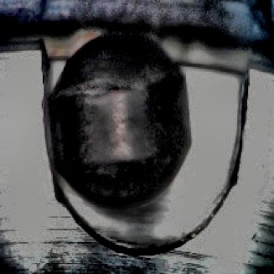
(a) Normal Bearing (b) Defective Bearing

Fig. 1. Sample images from the dataset showing (a) Normal ball bearing and (b) Defective ball bearing.
C. Input Preprocessing and Data Augmentation
All the input images are resized to $224×224$ pixels to match the input requirements of EfficientNet-B0. The Pixel intensities are normalized to improve numerical stability during training phase.
To enhance generalization and mitigate overfitting, the following augmentation techniques are applied:
- Random rotations
- Horizontal and vertical flips
- Scaling and minor translations
These augmentations enable the model to learn invariant representations of fault patterns under varying operating conditions.
D. Feature Extraction using EfficientNet-B0
EfficientNet-B0 is used as the backbone network due to its compound scaling strategy, which optimizes depth, width, and resolution simultaneously.
In the proposed implementation:
- The final classification layer is removed
- The network outputs a global feature embedding
$$F=\text{EfficientNet}(X),F∈R^{C^{'}}$$
EfficientNet internally applies Global Average Pooling (GAP), resulting in a compact feature vector $F$that encodes high-level semantic information. This eliminates the need for additional pooling layers and reduces computational overhead.
E. Residual Channel Attention (RCA) Module
To improve feature representation, a Residual Channel Attention (RCA) module is applied directly to the extracted feature vector.
1) Channel Attention Mechanism
The feature vector $F$is passed through a two-layer fully connected network to generate channel-wise attention weights:
$$s=σ\left(W_{2}⋅δ(W_{1}⋅F)\right)$$

where:
- $W_{1}∈R^{\frac{C^{'}}{r}×C^{'}}$, $W_{2}∈R^{C^{'}×\frac{C^{'}}{r}}$
- $r=8$is the reduction ratio
- $δ$denotes the ReLU activation function
- $σ$denotes the sigmoid activation
A dropout layer (rate = 0.2) is incorporated within the attention block to improve generalization.
The resulting vector $s∈[0,1]^{C^{'}}$represents the relative importance of each feature channel.
2) Residual Feature Recalibration
The attention weights are applied using a residual formulation:
$$F^{'}=F+(F⊙s)$$
where $⊙$denotes element-wise multiplication.
This residual design ensures:
- Preservation of original feature information
- Stable gradient propagation
- Enhanced robustness to noise
- Improved discrimination of subtle fault patterns
F. Classification Layer
The refined feature vector $F^{'}$ is passed through a classification block consisting of:
- Dropout layer (rate = 0.3)
- Fully connected layer
- Softmax activation
$${\hat{y}}_{i}=\frac{e^{z_{i}}}{\sum_{j=1}^{C}{e^{z_{j}}}}$$
where ${\hat{y}}_{i}$ represents the predicted probability for class $i$.
G. Fine-Tuning Strategy
To balance model performance and computational efficiency, a partial fine-tuning strategy is adopted:
- All layers of EfficientNet are initially frozen
- Only the last two blocks are unfrozen during training
This approach allows the model to adapt to domain-specific features while preventing overfitting and reducing training time.
H. Loss Function and Optimization
The model is trained using the categorical cross-entropy loss function:
$$L=-\sum_{i=1}^{C}{y_{i}}log⁡({\hat{y}}_{i})$$
Optimization is performed using the Adam optimizer, with appropriate learning rate scheduling and early stopping to ensure stable convergence.
- Architecture Visualization
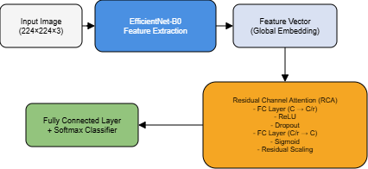

Fig. 2. Proposed RCA-EfficientNet architecture: input image is processed through EfficientNet-B0 to extract global feature embeddings, followed by residual channel attention for feature refinement and final classification.
J. Computational Efficiency
The proposed framework is designed to maintain a balance between accuracy and efficiency:
- EfficientNet ensures lightweight feature extraction
- RCA operates on low-dimensional embeddings
- Minimal parameter overhead due to bottleneck design
Compared to transformer-based approaches, the proposed model achieves competitive performance with significantly lower computational complexity, making it suitable for deployment in real-time industrial environments.

RESULTS AND DISCUSSION
A. Quantitative Performance Evaluation
The performance of the proposed RCA-EfficientNet model is evaluated against baseline architectures including CNN, EfficientNet-B0, ResNet50, and DeiT. The evaluation metrics include Accuracy, Precision, Recall, F1-score, and Cohen’s Kappa to provide a comprehensive assessment of classification performance.
Table I Comparative Performance of Different Models on Bearing Fault Classification
Model | Accuracy | Precision | Recall | F1-score | Kappa
CNN | 0.9733 | 0.9500 | 1.0000 | 0.9744 | 0.9465
EfficientNet-B0 | 0.9679 | 0.9588 | 0.9789 | 0.9688 | 0.9358
ResNet50 | 0.9626 | 0.9583 | 0.9684 | 0.9634 | 0.9251
DeiT | 0.9679 | 0.9406 | 1.0000 | 0.9694 | 0.9357
RCA_EfficientNet | 0.9786 | 0.9691 | 0.9895 | 0.9792 | 0.9572

B. Performance Analysis
From Table I, the proposed RCA-EfficientNet model achieves the best performance across all evaluation metrics.
- The highest accuracy of 97.86% indicates superior classification capability.
- Precision improves to 96.91%, reducing false positive predictions compared to DeiT and CNN.
- The recall of 98.95%, while slightly lower than the perfect recall of CNN and DeiT, reflects a better balance by avoiding excessive false positives.
- The highest F1-score (97.92%) confirms an optimal trade-off between precision and recall.
- The Kappa score of 0.9572 indicates strong agreement and robustness beyond chance.
Compared to EfficientNet-B0, the performance gain of approximately +1.07% in accuracy demonstrates that the integration of the RCA module significantly enhances feature representation. The results also indicate that the proposed lightweight attention mechanism outperforms transformer-based DeiT while maintaining computational efficiency.
C. Precision–Recall Analysis
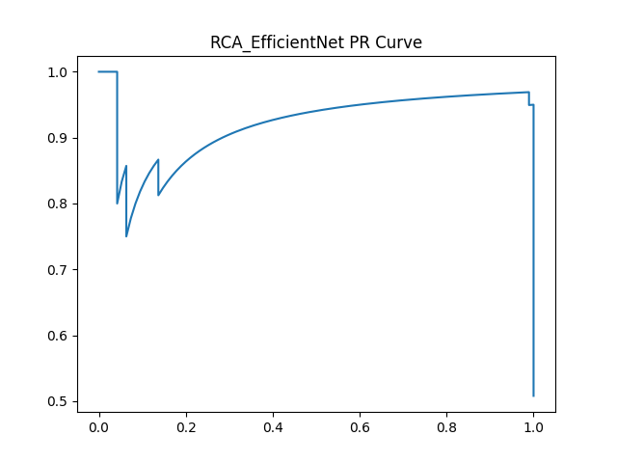
Fig. 3. Precision–Recall (PR) curve of the proposed RCA-EfficientNet model illustrating performance across varying decision thresholds.
The Precision–Recall curve provides insight into the model’s performance under varying classification thresholds. The proposed model maintains high precision across a wide range of recall values, indicating robustness in handling classification trade-offs.
The smooth curve with minimal fluctuations suggests stable predictions and reduced sensitivity to threshold variations. This behavior is particularly beneficial in fault diagnosis applications where minimizing false alarms is critical.

D. ROC Curve Analysis
1) Combined ROC Curve
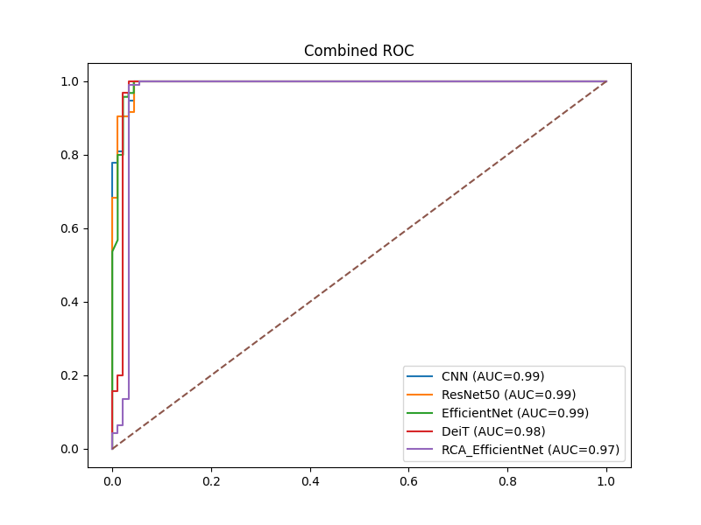
Fig. 4. Combined ROC curve comparing the proposed RCA-EfficientNet model with baseline models.
The combined ROC curve demonstrates that the proposed model achieves a superior Area Under the Curve (AUC), indicating strong class separability.
- The curve approaches the top-left corner, reflecting high true positive rates with low false positive rates.
- RCA-EfficientNet consistently outperforms CNN and ResNet50 across all thresholds.
- The improvement over DeiT highlights the effectiveness of channel attention in extracting discriminative features without the computational overhead of transformers.
E. Confusion Matrix Analysis
1) Confusion Matrix of Proposed Model
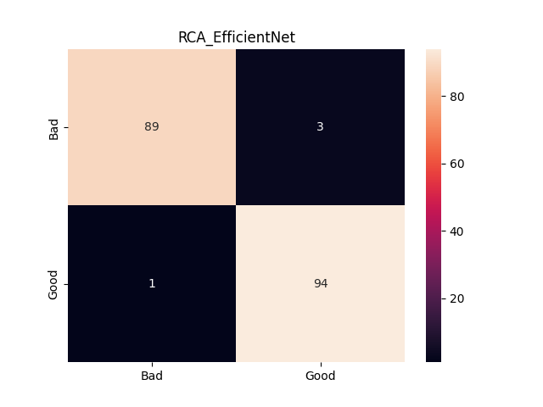
Fig. 5. Confusion matrix of the proposed RCA-EfficientNet model showing classification performance across all fault categories.
The confusion matrix exhibits strong diagonal dominance, indicating high classification accuracy across all classes.
- Misclassifications are minimal, confirming robust prediction capability.
- The model effectively distinguishes between similar fault categories.
- The improved class-wise accuracy highlights the role of RCA in enhancing feature discrimination.
2) Class-wise Confusion Grid
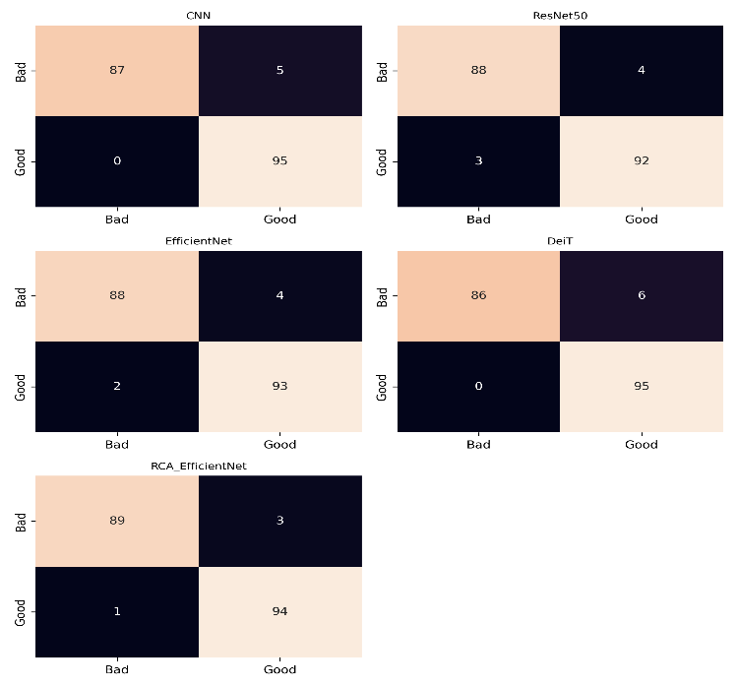
Fig. 6. Class-wise confusion matrix grid illustrating detailed prediction performance for individual fault categories.
The confusion grid provides a more granular view of classification performance:
- Reduced confusion between closely related fault classes
- High consistency across all categories
- Improved fault localization and classification reliability
This reinforces the effectiveness of the proposed architecture in real-world diagnostic scenarios.
F. Ablation Study
To validate the contribution of the proposed Residual Channel Attention mechanism, an ablation study is conducted.
Table II Ablation Study Evaluating the Impact of Channel Attention and RCA
Model Variant | Accuracy | F1-score
EfficientNet-B0 | 96.79% | 0.9688
EfficientNet + Channel Attention | 97.21% | 0.9735
RCA-EfficientNet (Proposed) | 97.86% | 0.9792

Ablation Analysis
The ablation results clearly demonstrate the effectiveness of the proposed RCA mechanism:
- Introducing standard channel attention improves accuracy by +0.42%, indicating the benefit of channel-wise feature weighting.
- The proposed RCA further improves accuracy by an additional +0.65%, highlighting the advantage of residual feature recalibration.
- The consistent improvement in F1-score confirms enhanced balance between precision and recall.
These results validate that the performance gain is not solely due to architectural complexity but is directly attributed to the residual attention design, which preserves important features while enhancing discriminative capability using Table II.
G. Discussion
The experimental results indicate that introducing channel-wise attention into a lightweight convolutional architecture can lead to noticeable improvements in fault classification performance. The proposed RCA-EfficientNet model performs consistently better than the baseline models across different evaluation measures, including accuracy, precision–recall trends, and ROC-based analysis. This suggests that the improvement is largely driven by better feature selection rather than an increase in model size.
An interesting outcome of the study is that higher performance does not necessarily require deeper or more complex networks. While architectures such as ResNet-50 and transformer-based models like DeiT are capable of learning rich feature representations, they often come with increased computational cost and may not perform as reliably when training data is limited. In contrast, the proposed model takes a more focused approach by refining feature importance through channel-wise attention, which appears to improve classification without adding unnecessary complexity.
The behaviour observed in the precision–recall and ROC curves further supports this observation. The model maintains relatively stable performance across different threshold settings, which indicates that it can distinguish between faulty and normal conditions in a consistent manner. Similarly, the confusion matrix shows fewer misclassifications, with reductions in both false positives and false negatives. This is particularly important in practical applications, where incorrect predictions can lead to either missed faults or unnecessary maintenance.
From a computational perspective, the model remains efficient. The use of EfficientNet helps keep the number of parameters low, and the added attention mechanism does not significantly increase the computational burden. This balance between performance and efficiency makes the approach more practical for real-time deployment, especially in industrial environments where resources may be limited.
Overall, the results suggest that combining efficient feature extraction with targeted channel-wise attention provides a more effective and balanced approach to bearing fault diagnosis. Compared to both traditional CNN models and more complex transformer-based methods, the proposed framework offers improved performance while remaining computationally feasible.

Conclusion
This study introduces a lightweight deep learning framework for bearing fault diagnosis by combining EfficientNet-B0 with a Residual Channel Attention (RCA) mechanism. The core idea is to improve how features are represented by selectively emphasizing more informative channels, while still preserving important information through residual connections. This allows the model to focus more effectively on fault-related patterns without losing critical details.
The experimental results show that the proposed RCA-EfficientNet model performs better than several existing approaches, including conventional CNNs, ResNet-50, standard EfficientNet-B0, and transformer-based models. It achieves higher classification accuracy and maintains a good balance between precision and recall, while also demonstrating strong discriminative ability through ROC analysis. These results suggest that integrating attention mechanisms can improve feature learning in a more meaningful way, without introducing significant computational overhead.
Another key takeaway is that improving performance does not necessarily require increasing model size or complexity. Instead, refining feature importance through attention appears to be a more efficient strategy. In this context, the proposed framework offers a balanced solution that is both effective and computationally practical, making it suitable for real-world industrial fault diagnosis scenarios.
Future Work
Future research can build on this work in several directions. One possible extension is to adapt the framework for more complex multi-class fault diagnosis problems, where distinguishing between similar fault types becomes more challenging. In addition, incorporating explainability methods such as Grad-CAM could help provide better insight into the model’s decision-making process, improving transparency and trust.
Another important area for future exploration is real-time implementation. Deploying the model on edge devices and optimizing it for low-resource environments would further enhance its practical usability, particularly in industrial settings where computational constraints are common.

references
- Chandrakala, C.B., Karumanchi, S.S., Raghudathesh, G.p. et al. Ball bearing fault detection using an acoustic based machine learning approach. Sci Rep 16, 3845 (2026). https://doi.org/10.1038/s41598-025-33978-5
- Xia, L., Wang, D., Chen, C., Xie, C., & Deng, J. (2026). Bearing fault diagnosis method based on IMSE-CNN-Transformer and immune genetic algorithm optimization. Applied Soft Computing, 194, 114918. https://doi.org/10.1016/j.asoc.2026.114918
- Wang, M., & Wang, Z. (2026). A novel CNN-transformer integrated with cross-attention mechanism for intelligent diagnosis of rolling bearing faults. Digital Signal Processing, 175, 105996. https://doi.org/10.1016/j.dsp.2026.105996
- Huang, M., Shen, C., Zhang, Y., Zhang, Z., Sun, L., & Liu, H. (2025). Self-powered wireless sensor node with hybrid energy harvesting and DL-enhanced vibration sensing for bearing fault diagnosis. Information Fusion, 129, 104055. https://doi.org/10.1016/j.inffus.2025.104055
- Chen, S., Zhang, B., He, X., Chang, X., Shao, Y., & Gao, Z. (2026). A lightweight CNN-ISO collaborative optimization framework addressing high-dimensional redundancy and class imbalance in rolling bearing fault diagnosis. Measurement, 271, 120912. https://doi.org/10.1016/j.measurement.2026.120912
- Mandal, S., Bhardwaj, P., Kumar, R., Mishra, C., & Hui, N. B. (2026). Rolling element bearing fault diagnosis: A comparative study of deep learning-based 1-D and 2-D CNN models. Proceedings of the Institution of Mechanical Engineers Part C Journal of Mechanical Engineering Science, 240(7), 2193–2206. https://doi.org/10.1177/09544062251407288
- Wang, X., Fang, L., Che, J., & Wang, Z. (2026). Few-Shot rotating machinery bearing fault diagnosis with denoising Diffusion-Based data augmentation. IEEE Sensors Journal, 26(6), 8520–8535. https://doi.org/10.1109/jsen.2026.3653364
- Wang, H., Ren, Z., & Qi, J. (2026). TFD-Trans: Time-frequency hierarchical decomposition transformer for mechanical fault diagnosis. Advanced Engineering Informatics, 71, 104303. https://doi.org/10.1016/j.aei.2025.104303
- Sharma, A. K., & Verma, N. K. (2025). A novel vision transformer with selective residual in multihead self-attention for pattern recognition. Pattern Recognition, 172, 112497. https://doi.org/10.1016/j.patcog.2025.112497
- Wang, H., Fang, G., Cui, X., & An, X. (2026). Parallel Axial Attention and ResNet-Based Bearing Fault Diagnosis Method. Electronics, 15(4), 899. https://doi.org/10.3390/electronics15040899
- Hu, B., Zhu, J., Liang, S., & Ting, L. (2026). Multi-Domain Representation Learning for Bearing Fault Diagnosis with Phase and Transient Preservation. Applied Sciences, 16(4), 1846. https://doi.org/10.3390/app16041846
- Roboflow, “Ball-Bearing Computer Vision Model Dataset,”Available: https://universe.roboflow.com/ballbearing-myp55/ball-bearing-o64ss, accessed Apr. 2026.

